C programming

Name : Zeel Sonara

Course : C Programming

Structure of C programming:

#include<stdio.h>

void main()

{

printf(“zeel sonara”);

}

1. Hello Word Program in C

**Code:**

#include<stdio.h>

void main()

{

printf("Hello Word");

}

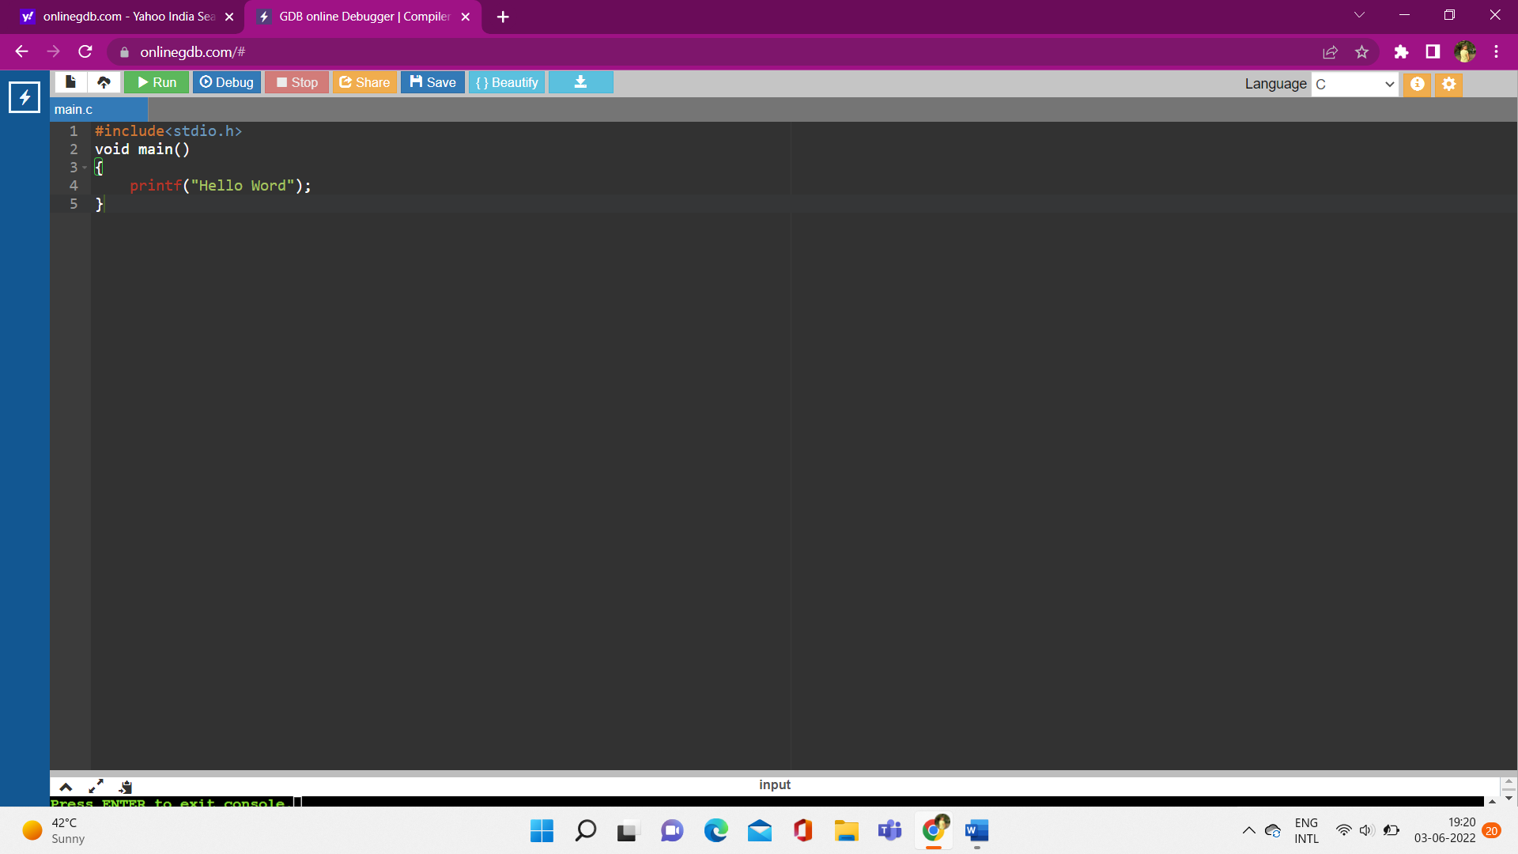

**Output:**

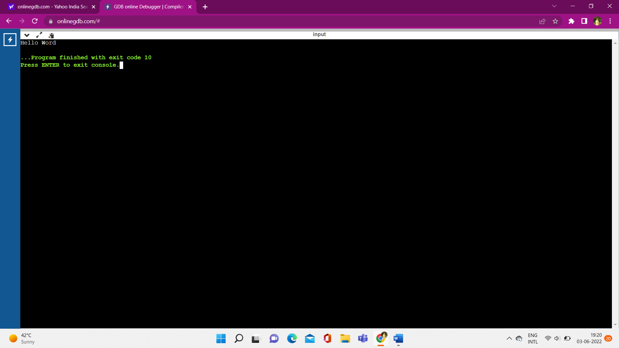

2. How to take input from user

**Code:**

#include<stdio.h>

void main()

{

int num;

printf("Enter any Number:");

scanf("%d",&num);

}

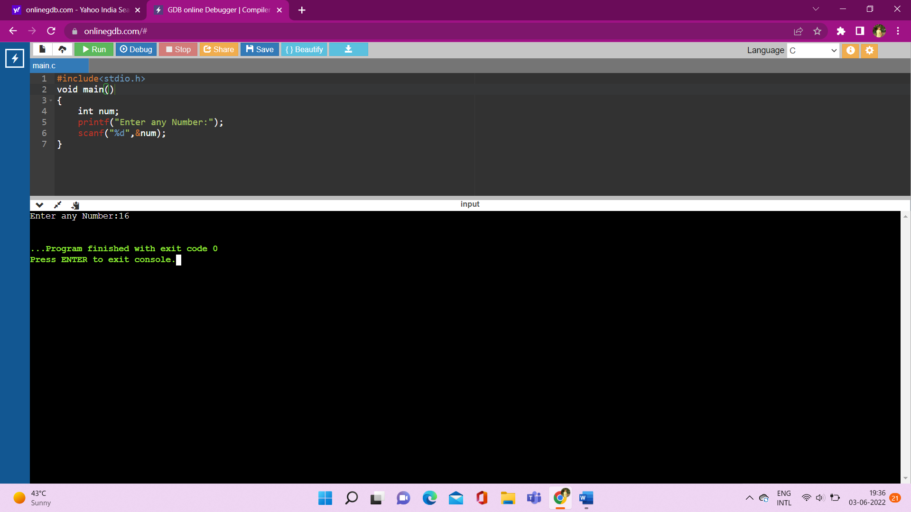

**Output:**



3. take two numbers from user and perform task: Addition, Subtraction, Multiplication, division, Modulo

**Code:**

#include<stdio.h>

void main()

{

int num1,num2;

printf("Enter Number1:");

scanf("%d",&num1);

printf("Enter Number2:");

scanf("%d",&num2);

printf("\naddition of two numbers:%d",num1+num2);

printf("\nsubtraction of two numbers:%d",num1-num2);

printf("\nmultiplication of two numbers:%d",num1*num2);

printf("\ndivision of two numbers:%d",num1/num2);

printf("\nmodulo of two numbers:%d",num1%num2);

}

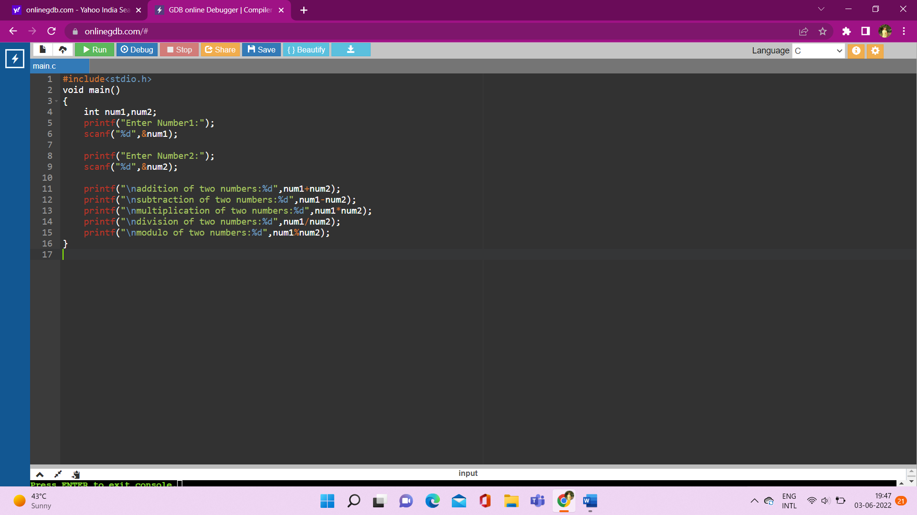

**Output:**

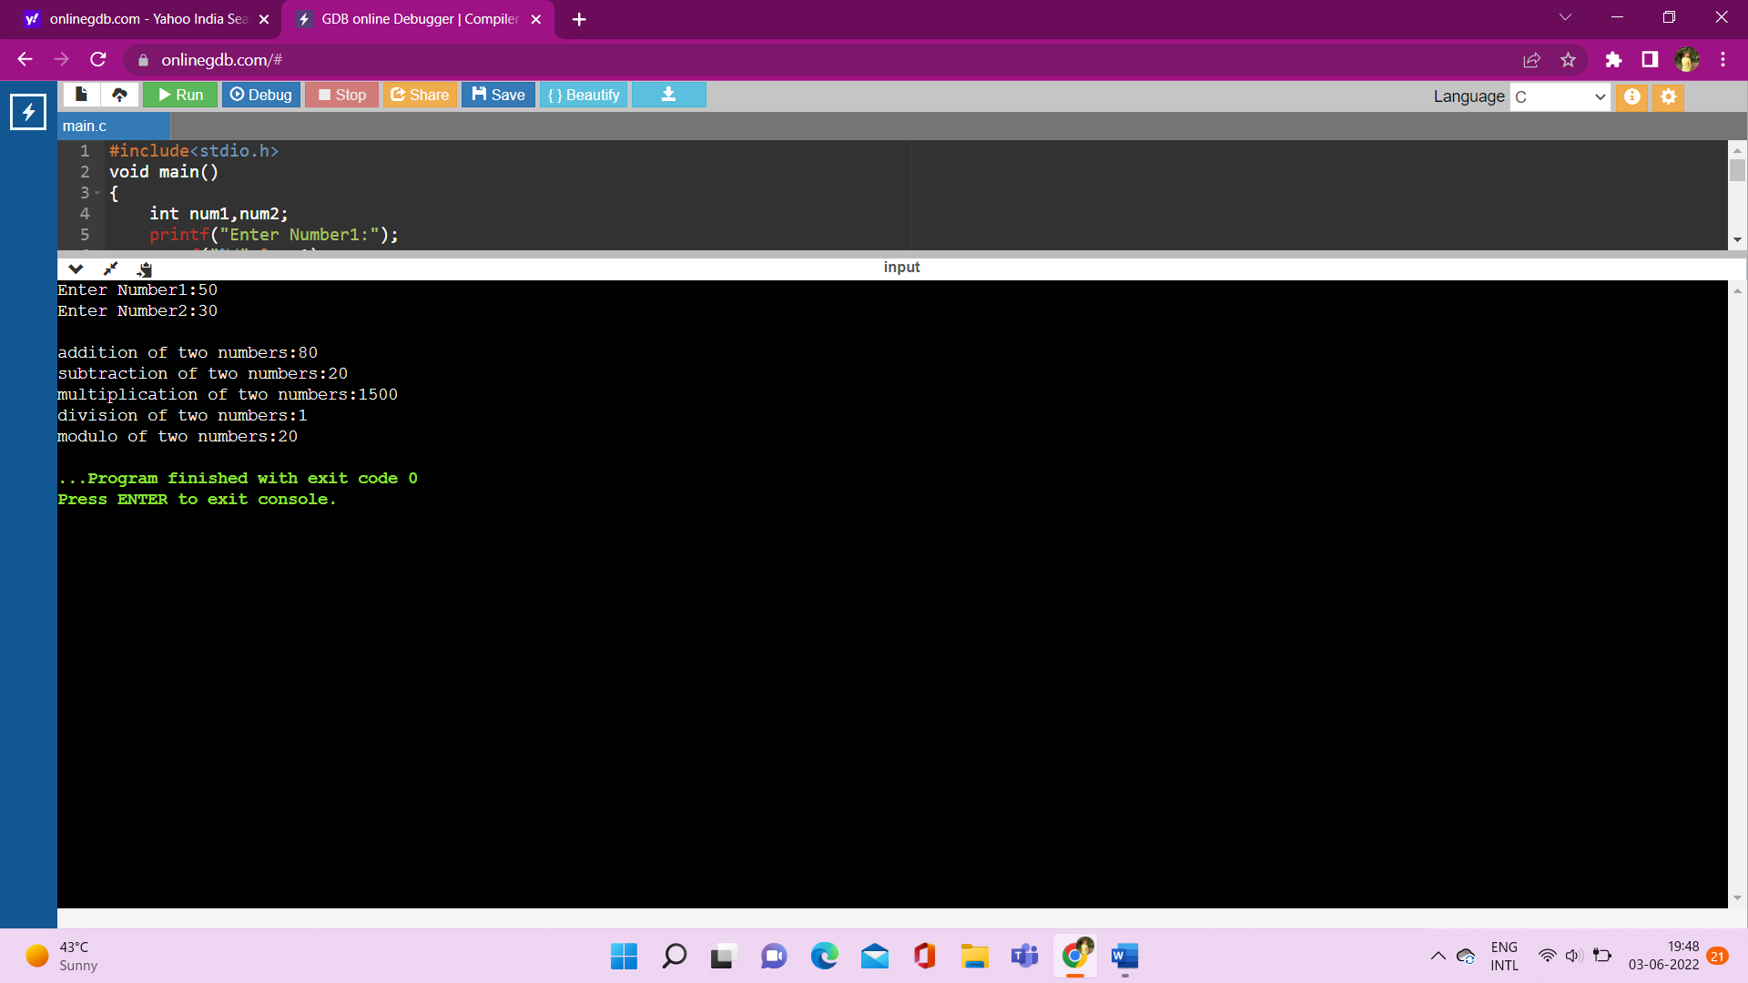

4. print my information

**Code:**

#include<stdio.h>

void main()

{

printf("-------------My Information-------------");

printf("\n\tName: Zeel Sonara");

printf("\n\tAge: 20");

printf("\n\tBirth date: 16/02/2002");

printf("\n\tCource: C/C++");

}

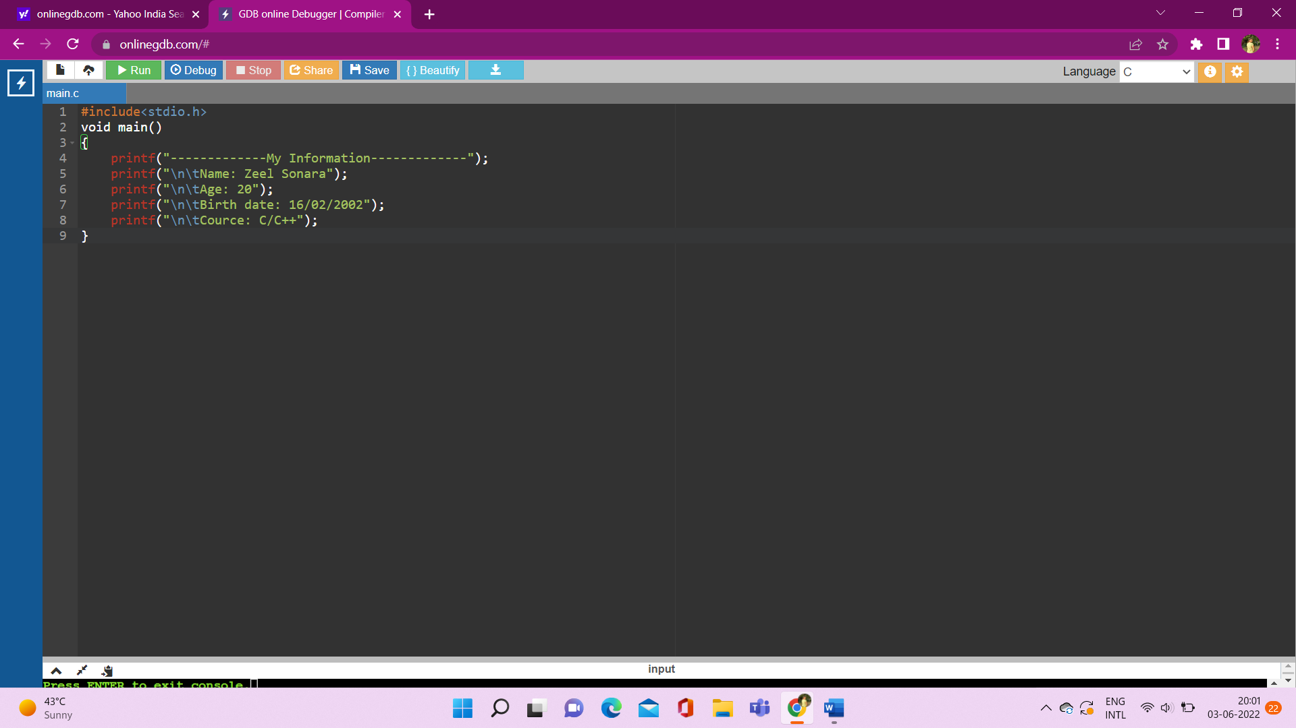

**Output:**

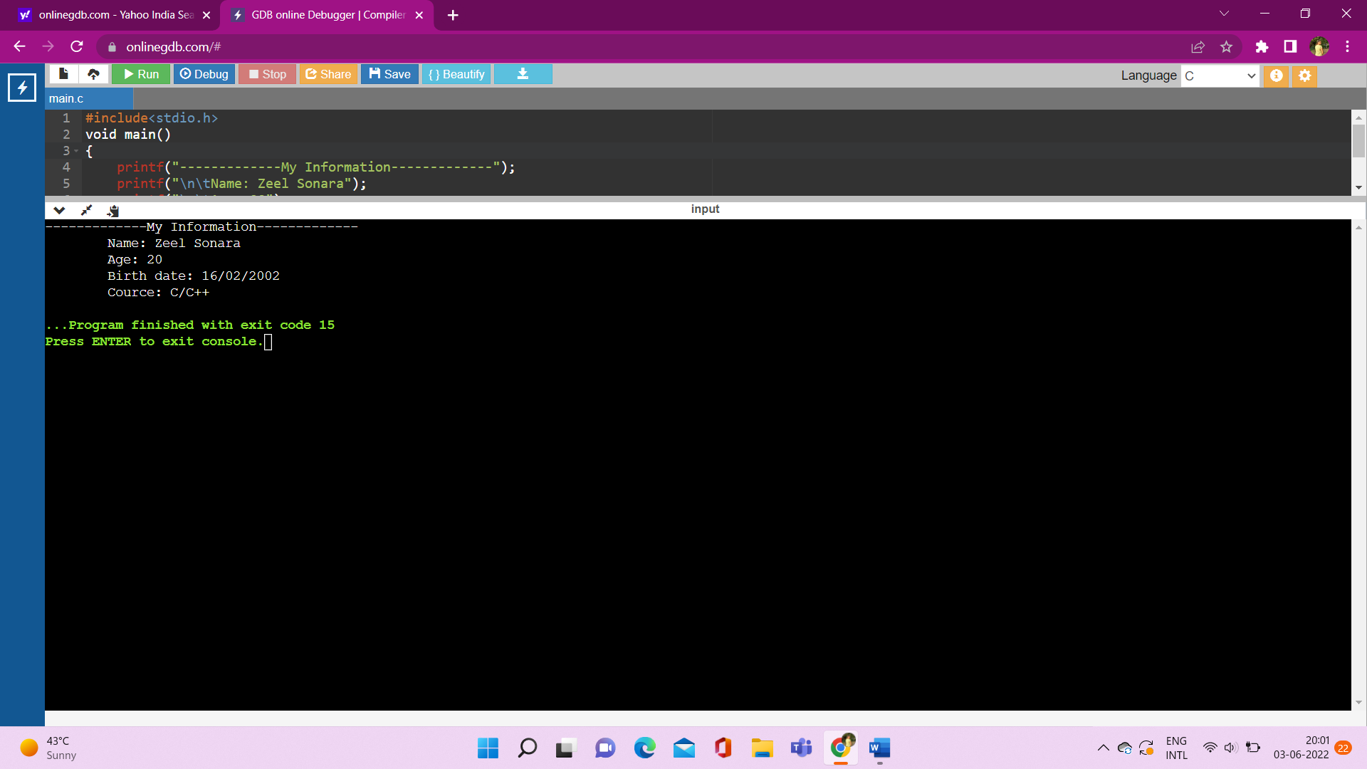

5. Swapping two numbers with third variable

**Code:**

#include<stdio.h>

void main()

{

int a,b,c;

printf("enter number1:");

scanf("%d",&a);

printf("enter number2:");

scanf("%d",&b);

printf("\nnumber1 before swapping:%d",a);

printf("\nnumber2 before swapping:%d",b);

c=a;

a=b;

b=c;

printf("\nnumber1 after swapping:%d",a);

printf("\nnumber2 after swapping:%d",b);

}

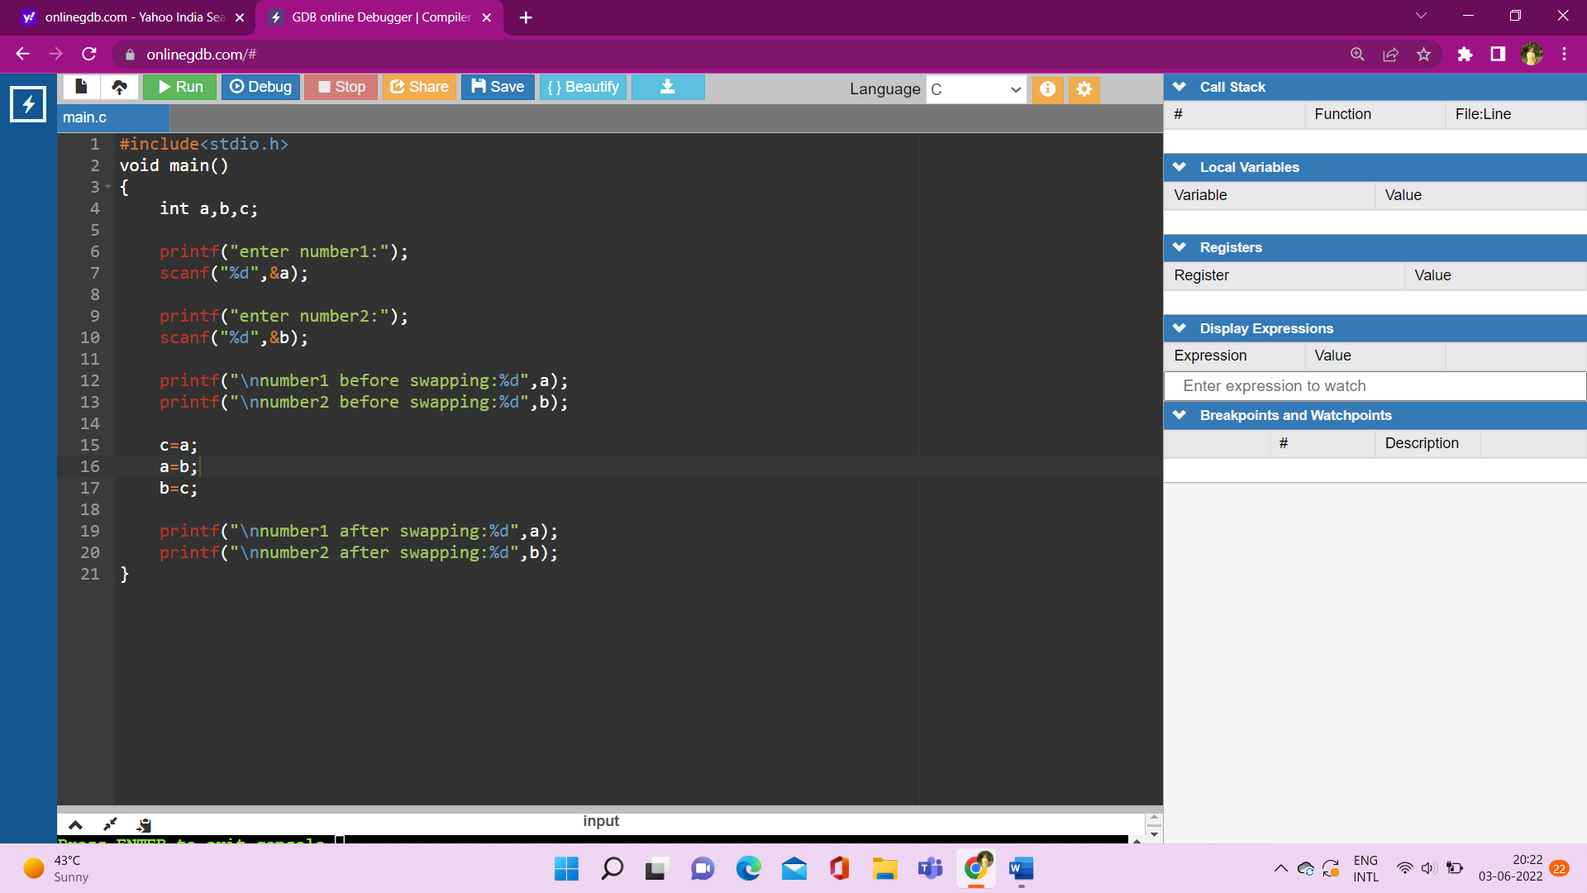

**Output:**

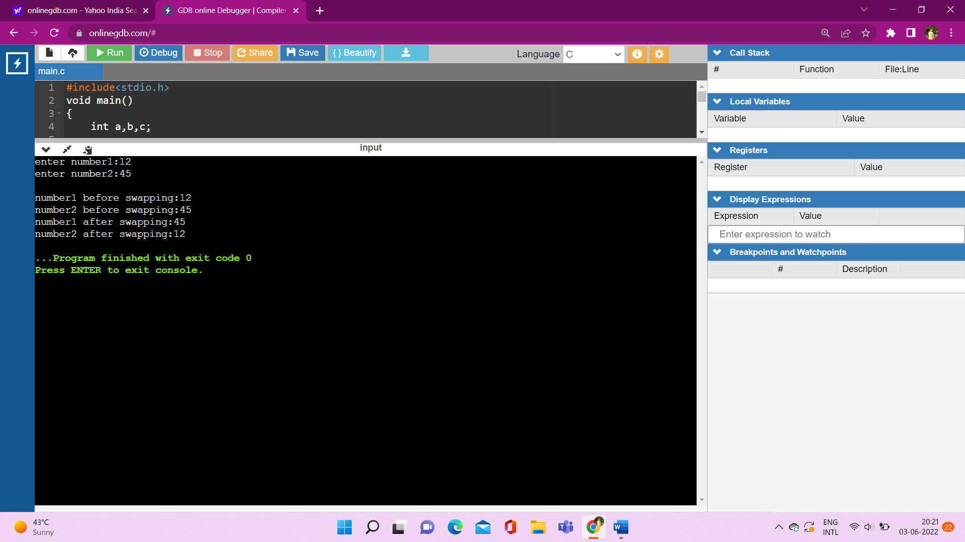

6. Swapping values of two variables without third variable

**Code:**

#include<stdio.h>

void main()

{

int a,b,c;

printf("enter number1:");

scanf("%d",&a);

printf("enter number2:");

scanf("%d",&b);

printf("\nnumber1 before swapping:%d",a);

printf("\nnumber2 before swapping:%d",b);

a=a+b;

b=a-b;

a=a-b;

printf("\nnumber1 after swapping:%d",a);

printf("\nnumber2 after swapping:%d",b);

}

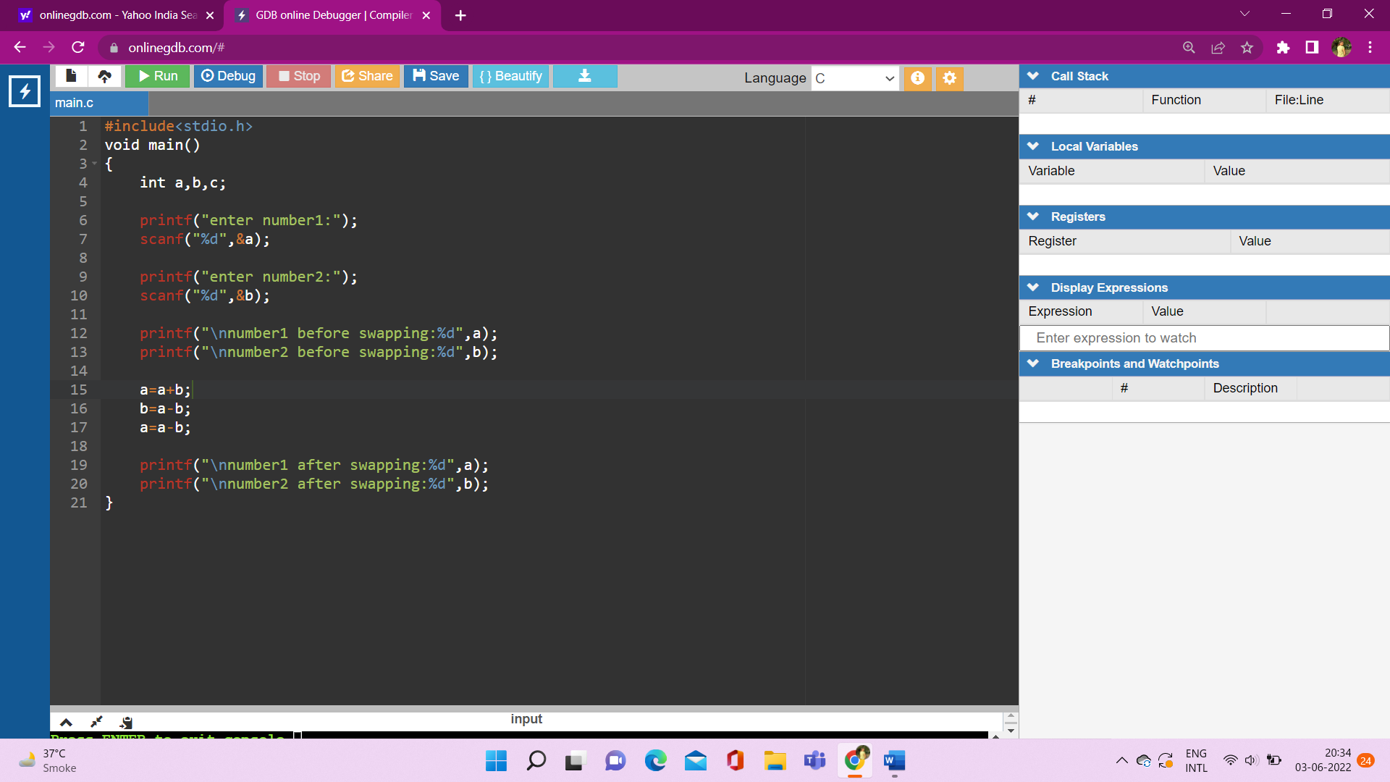

**Output:**

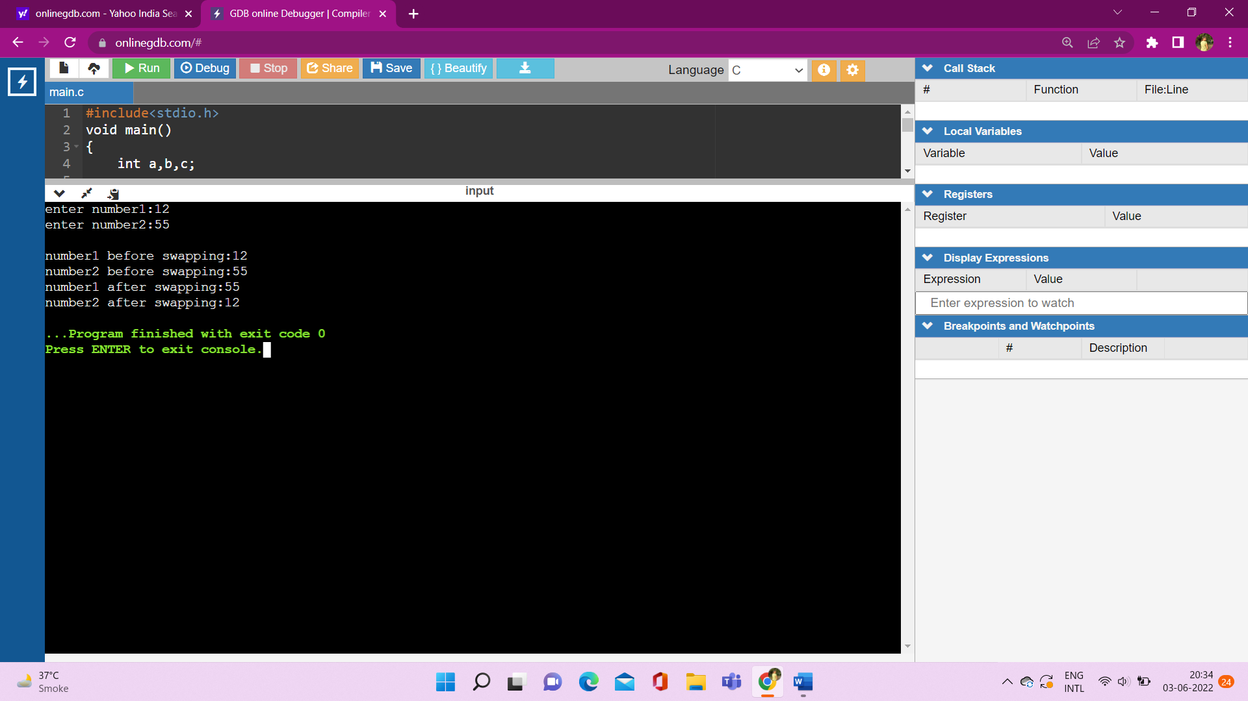

7. Take input from user about years and find months and days

**Code:**

#include<stdio.h>

void main()

{

int years;

printf("Enter years:");

scanf("%d",&years);

printf("\nmonths:%d",years*12);

printf("\ndays:%d",years*365);

}

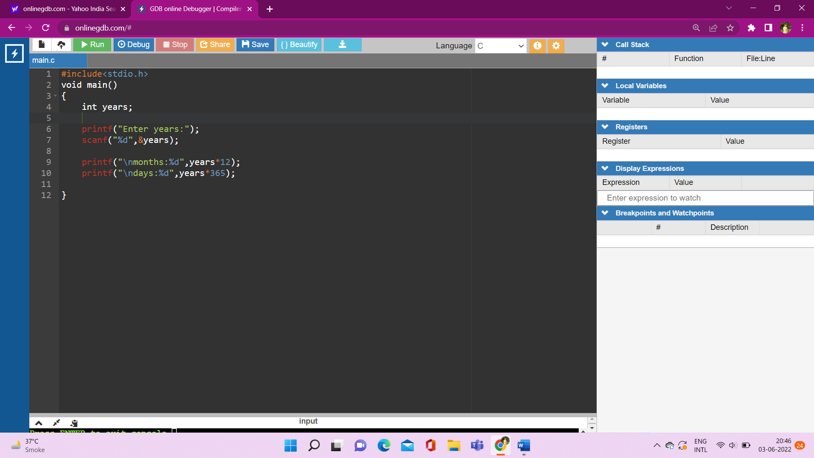

**Outout:**

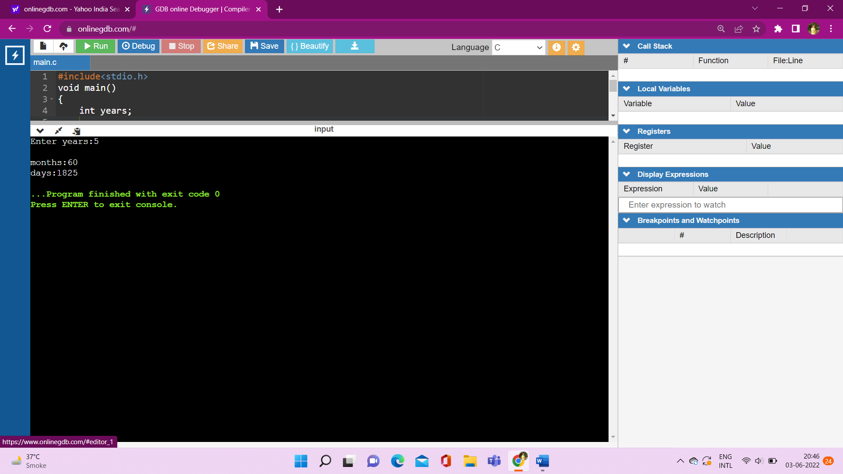

**8. Take input from user about months and find years and days**

**Code:**

#include<stdio.h>

void main()

{

int months;

printf("Enter months:");

scanf("%d",&months);

printf("\nyears:%d",months/12);

printf("\ndays:%d",months*365/12);

}

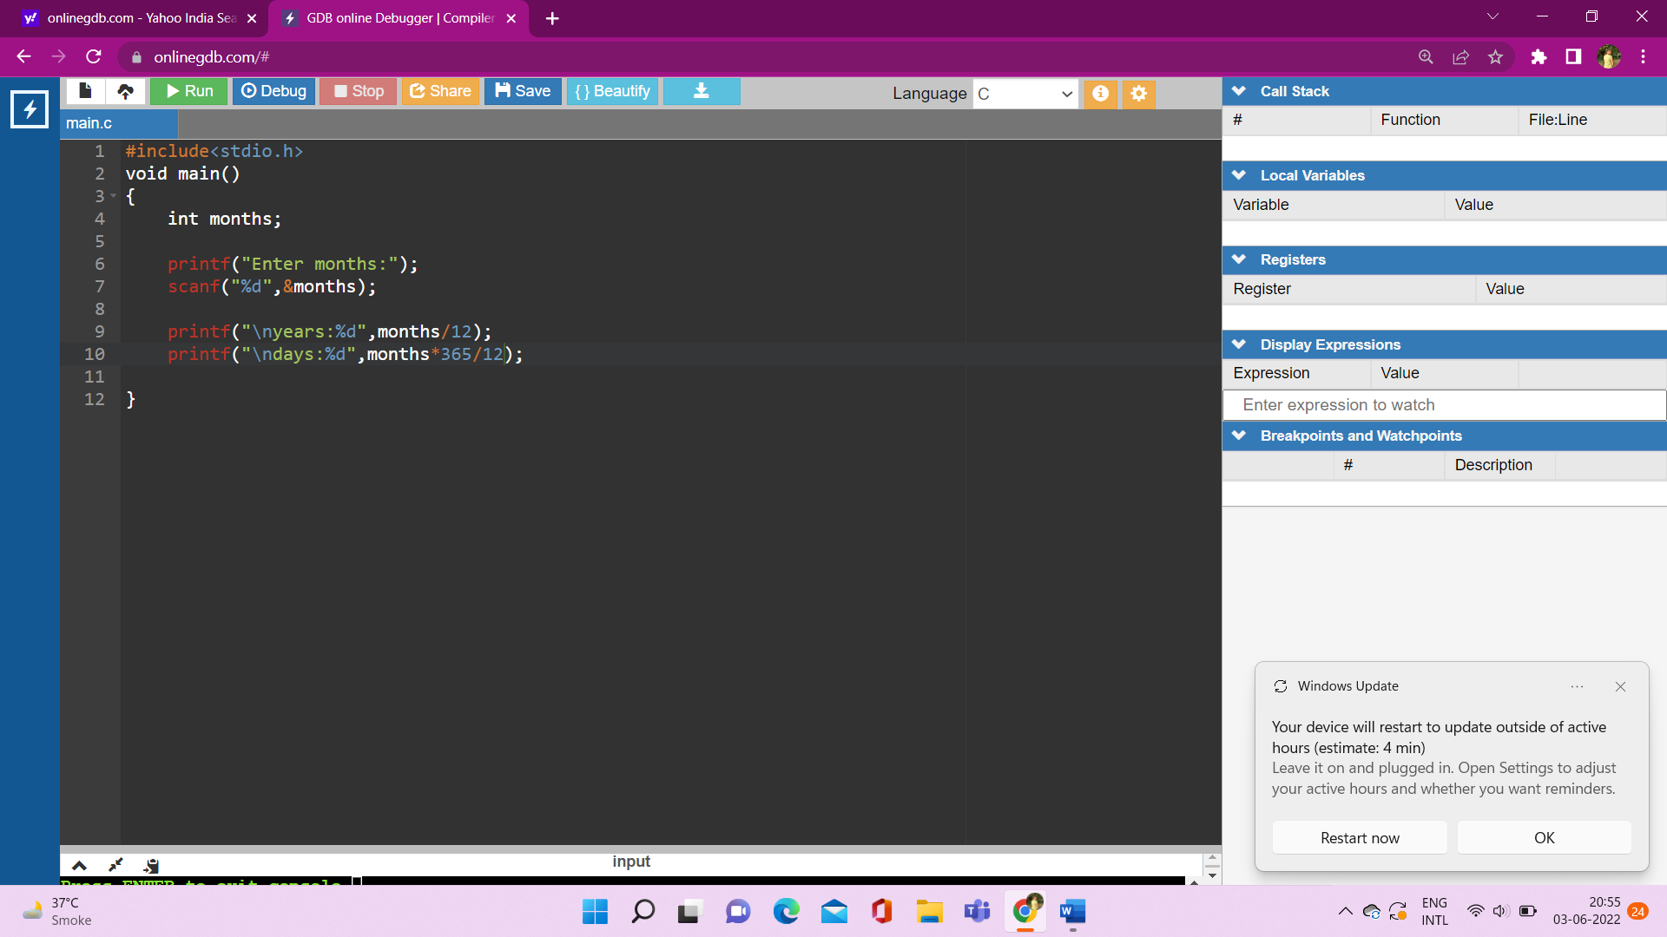

**Output:**

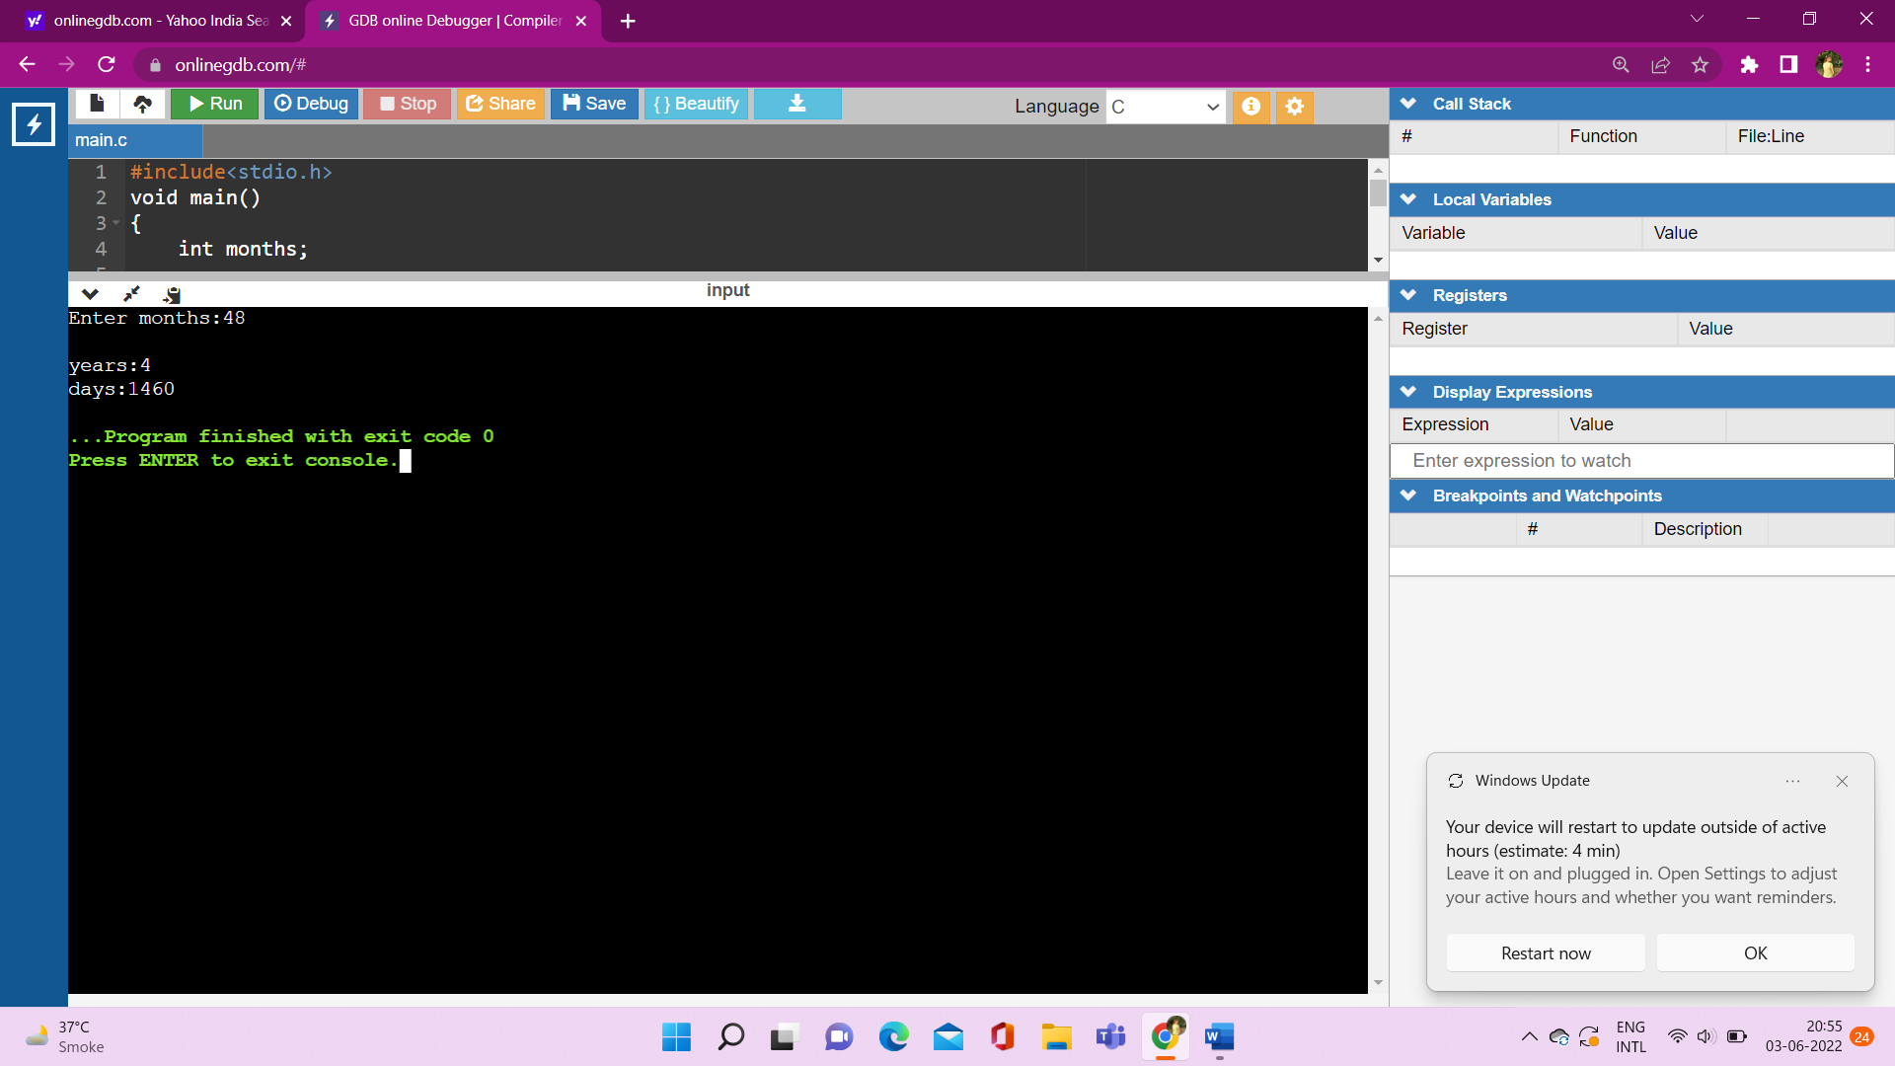

9. Take input from user about days and find years and months

**Code:**

#include<stdio.h>

void main()

{

float days;

printf("Enter days:");

scanf("%f",&days);

printf("\nyears:%f",days/365);

printf("\nmonths:%f",days*12/365);

}

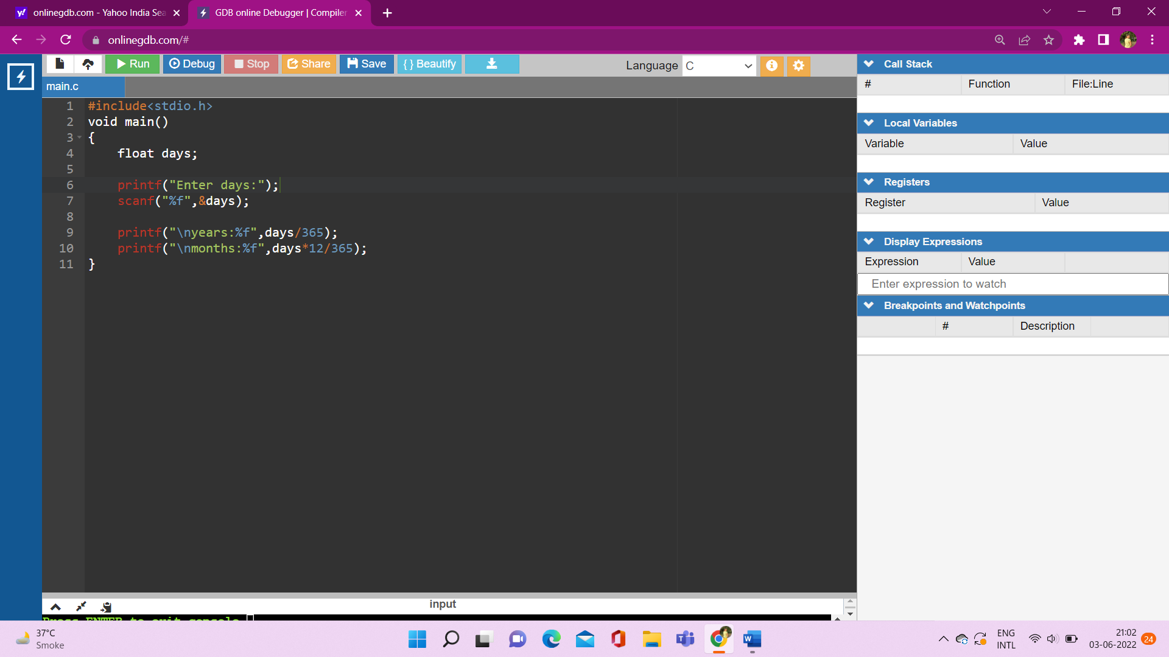

**Output:**

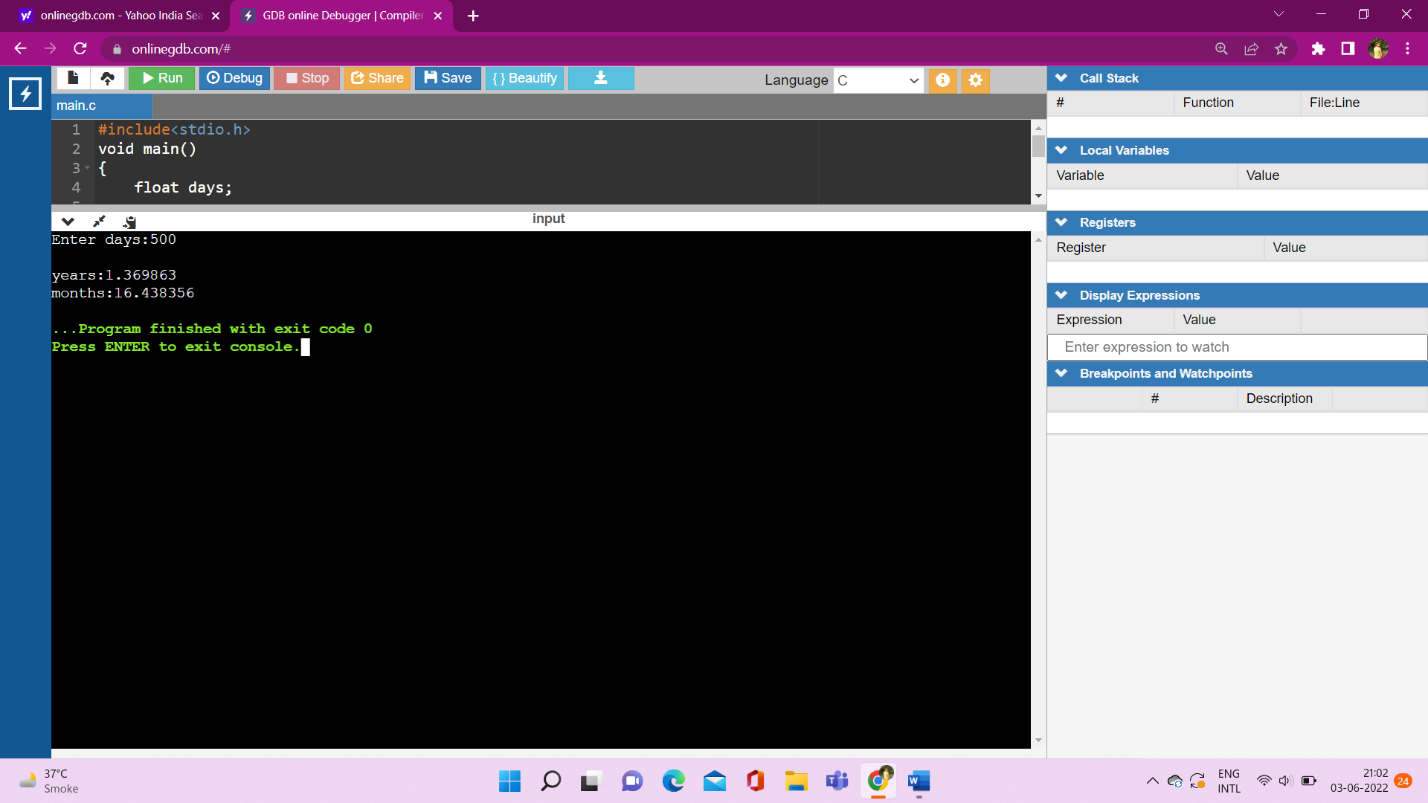

10. shorthand operator

**Code:**

#include<stdio.h>

void main()

{

float a,b,c,d;

printf("value of A:");

scanf("%f",&a);

a+=10;

printf("\nvalue of A:%f",a);

a-=10;

printf("\nvalue of A:%f",a);

a*=10;

printf("\nvalue of A:%f",a);

a/=10;

printf("\nvalue of A:%f",a);

}

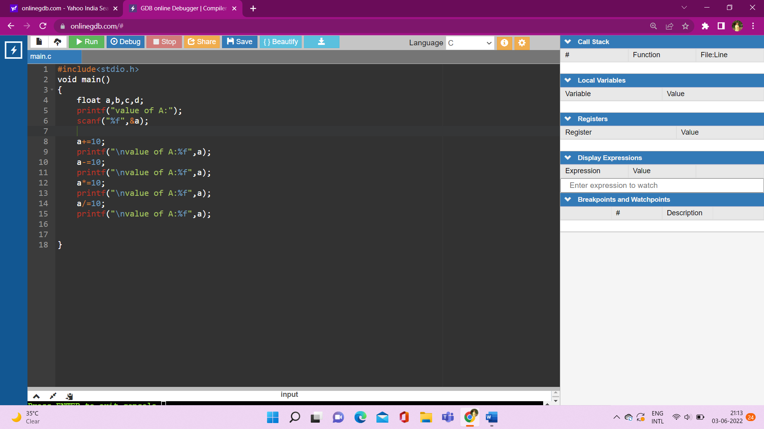

**Output:**

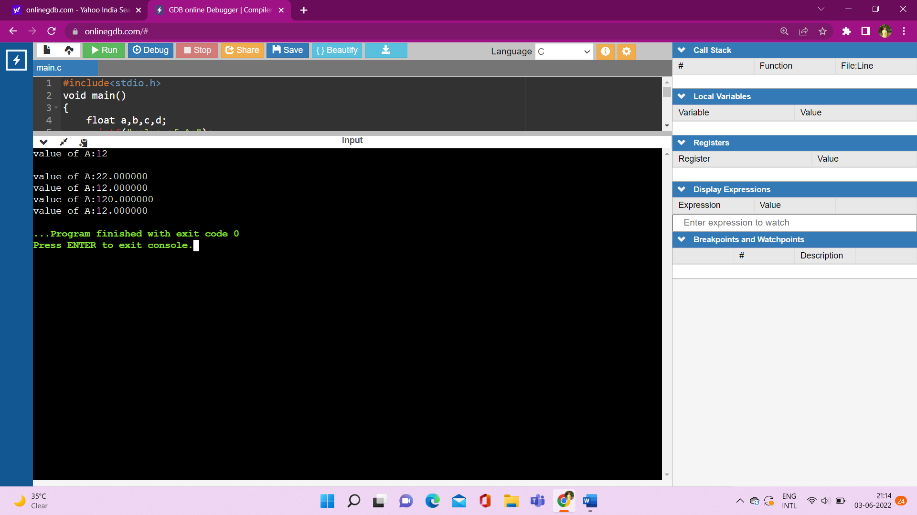

11. Unary operator

**Code:**

#include<stdio.h>

void main()

{

int a,b;

printf("Enter value of A:");

scanf("%d",&a);

a++;

printf("\nA:%d",a);

b=a++;

printf("\nB:%d",b);

// printf("\nA:%d",a)

b=++a;

printf("\nB:%d",b);

}

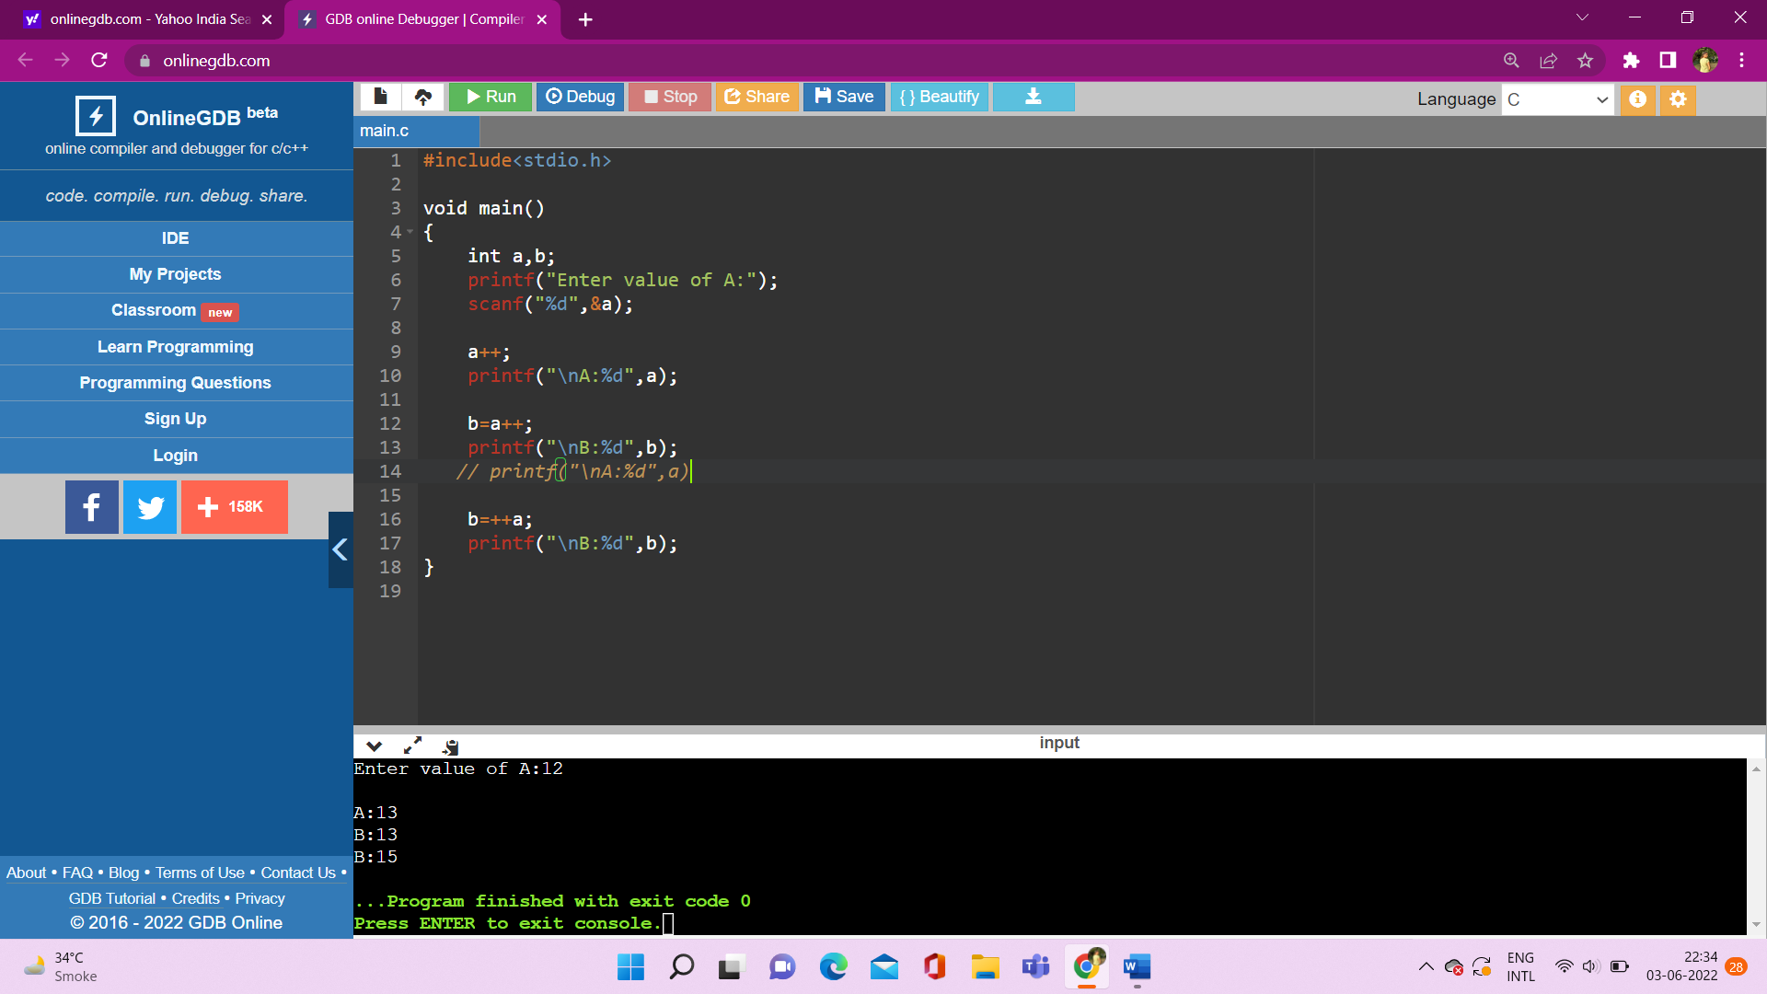

**Output:**

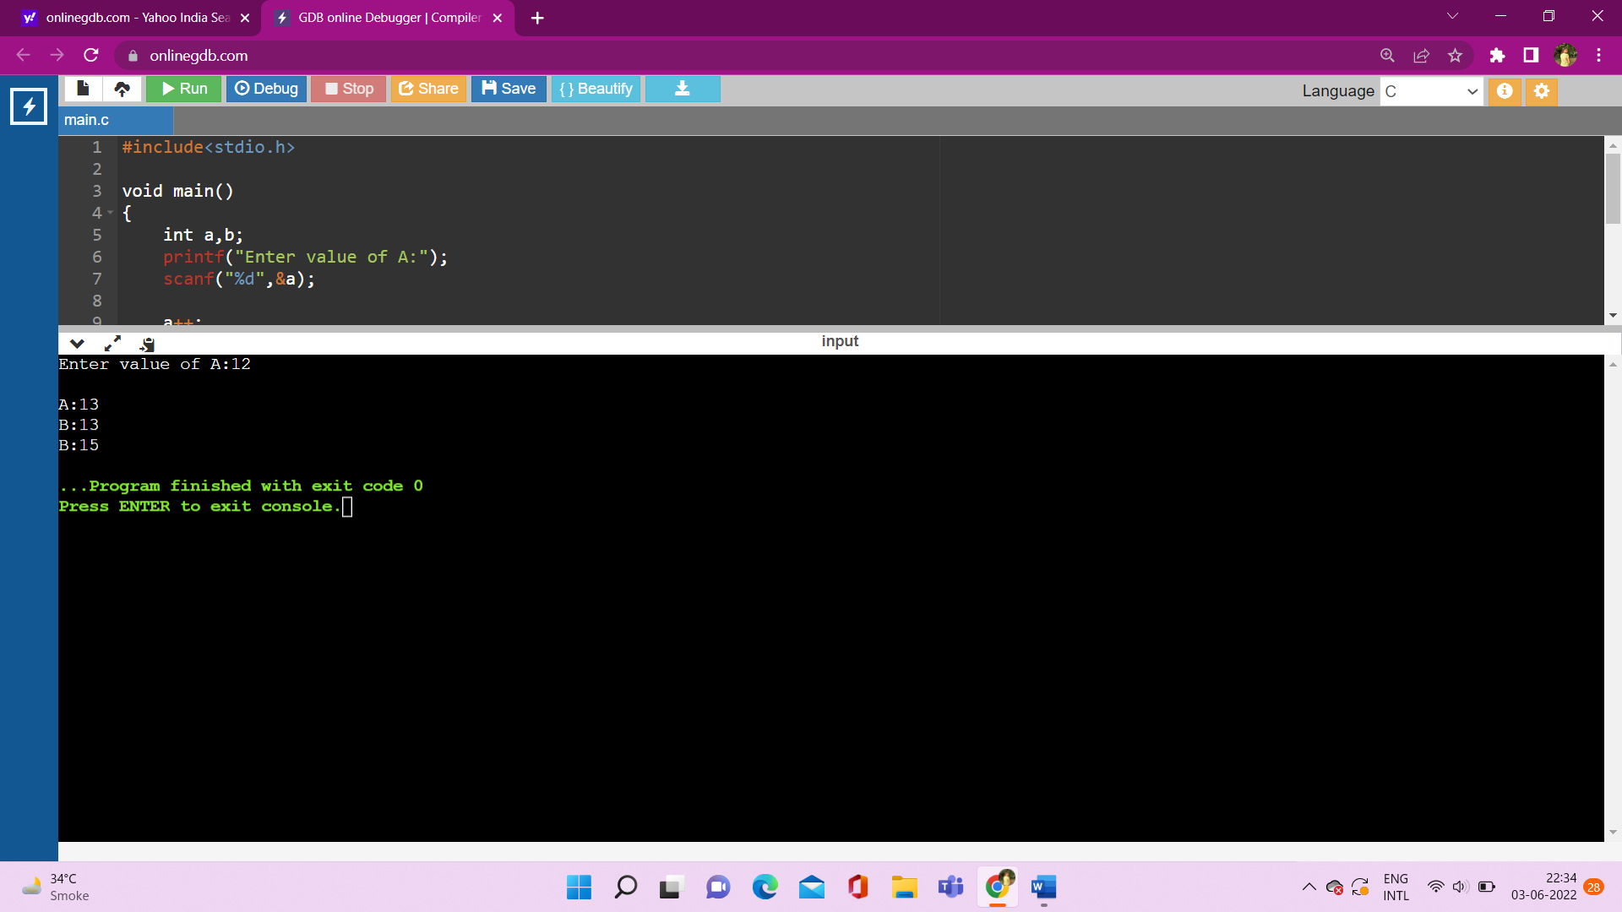

Conditional Statement:

**1) if statement**

* Syntax:

if(condition){

//statement

}

**2) if else statement**

* Syntax:

if(condition){

//statement

}

else{

}

**3) nested if else**

* Syntax:

if(condition){

if(condition){

//statement

}

else{

//statement

}

}

else{

if(condition){

//statement

}

else{

//statement

}

}

**4) if…….else if……else if…..else (if else ladder)**

* Syntax:

if(condition){

//statement

}

else if(condition){

//statement

}

else if(condition){

//statement

}

else if(condition){

//statement

}

else{

//statement

}

**5) switch case**

* Syntax:

Switch(expresion)

{

Case exp_1:

//statements….

Break;

Case exp_2:

//statements….

Break;

Case exp_3:

//statements….

Break;

Case exp_4:

//statements….

Break;

default:

//statements….

Break;

}

12. if statement

Code:

#include<stdio.h>

int main()

{

int age;

printf("enter your age:");

scanf("%d",&age);

if(age>=18)

{

printf("you are eligible for vote:");

}

}

* Output when number is less than fifteen

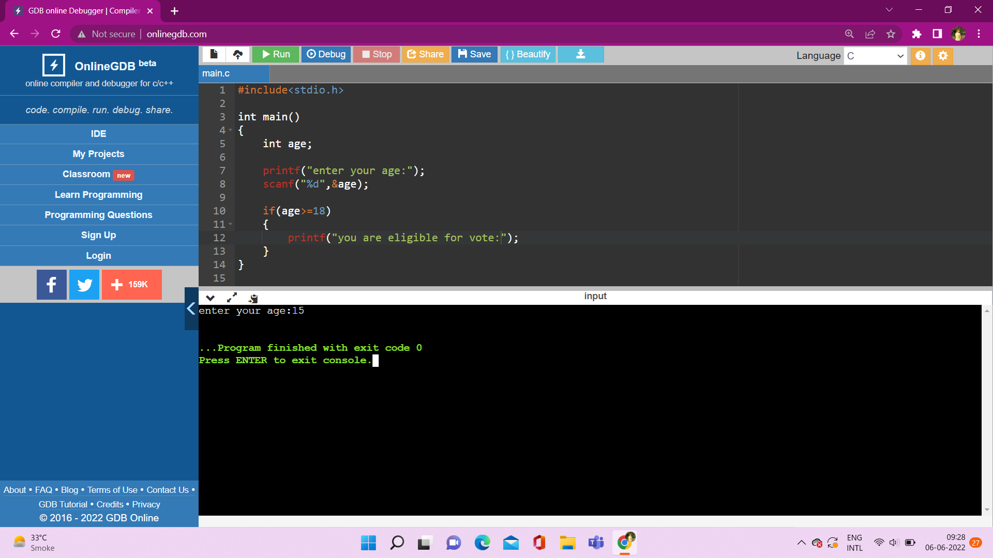

Output when number is equal to or greater than eighteen

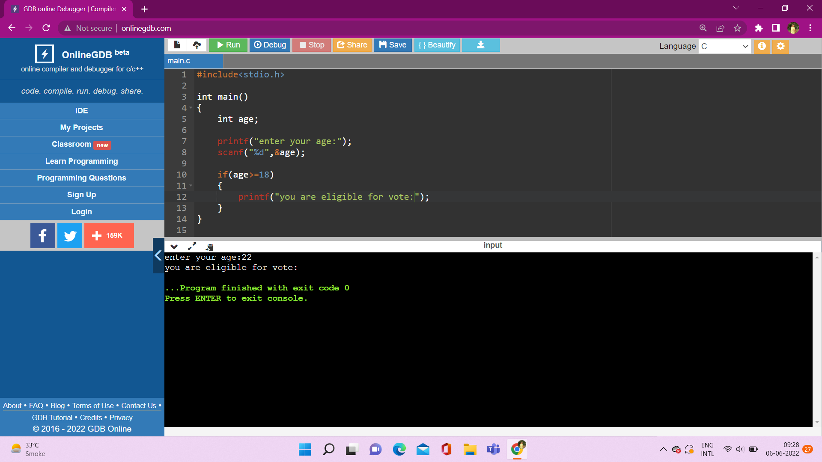

13. if else statement – odd even number

**Code:**

#include<stdio.h>

int main()

{

int num;

printf("enter a number:");

scanf("%d",&num);

if(num%2==0)

{

printf("even number");

}

else{

printf("odd number");

}

}

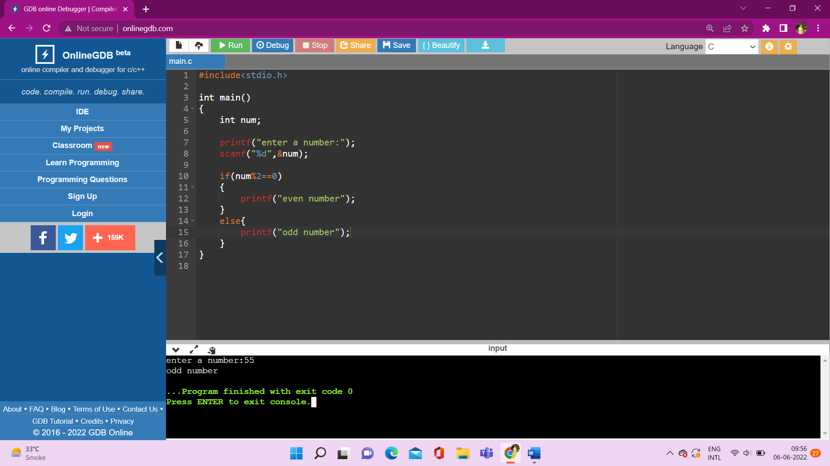

**Output:**



14. find largest number among three number

**Code:**

#include<stdio.h>

int main()

{

int a,b,c;

printf("enter three numbers:");

scanf("%d %d %d",&a,&b,&c);

if(a>b)

{

if(a>c){

printf("a is largest number");

} else{

printf("c is largest number");

}

}

else{

if(b>c){

printf("b is largest number");

} else{

printf("c is largest number");

}

}

}

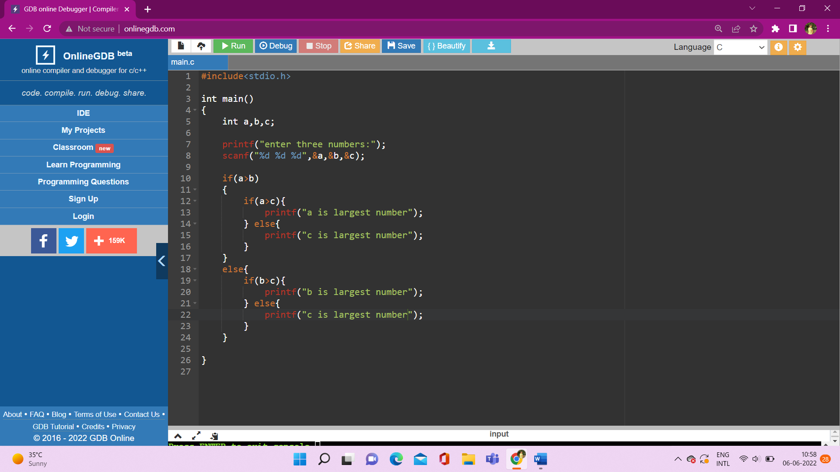

**Output:**

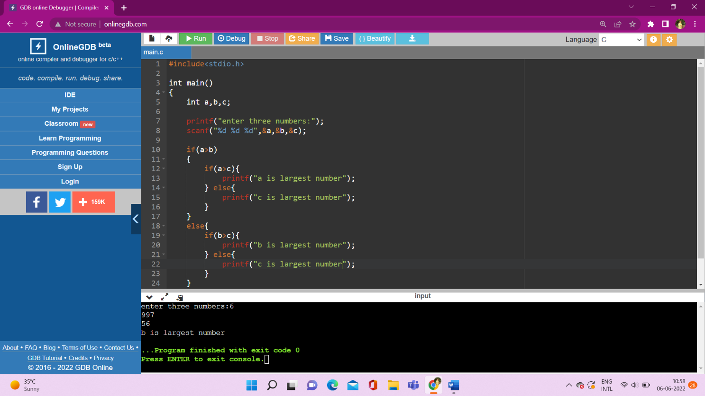

15. if else ladder

**Code:**

#include<stdio.h>

int main()

{

int marks;

printf("enter your marks");

scanf("%d",&marks);

if(marks<30)

{

printf("fail");

}

else if(marks>=30 && marks<40)

{

printf("D Grade");

}

else if(marks>=40 && marks<50)

{

printf("c+ Grade");

}

else if(marks>=50 && marks<60)

{

printf("c Grade");

}

else if(marks>=60 && marks<70)

{

printf("B+ Grade");

}

else if(marks>=70 && marks<80)

{

printf("B Grade");

}

else if(marks>=80 && marks<90)

{

printf("A Grade");

}

else if(marks>=90 && marks<=100)

{

printf("A+ Grade");

}

else{

printf("wrong marks");

}

}

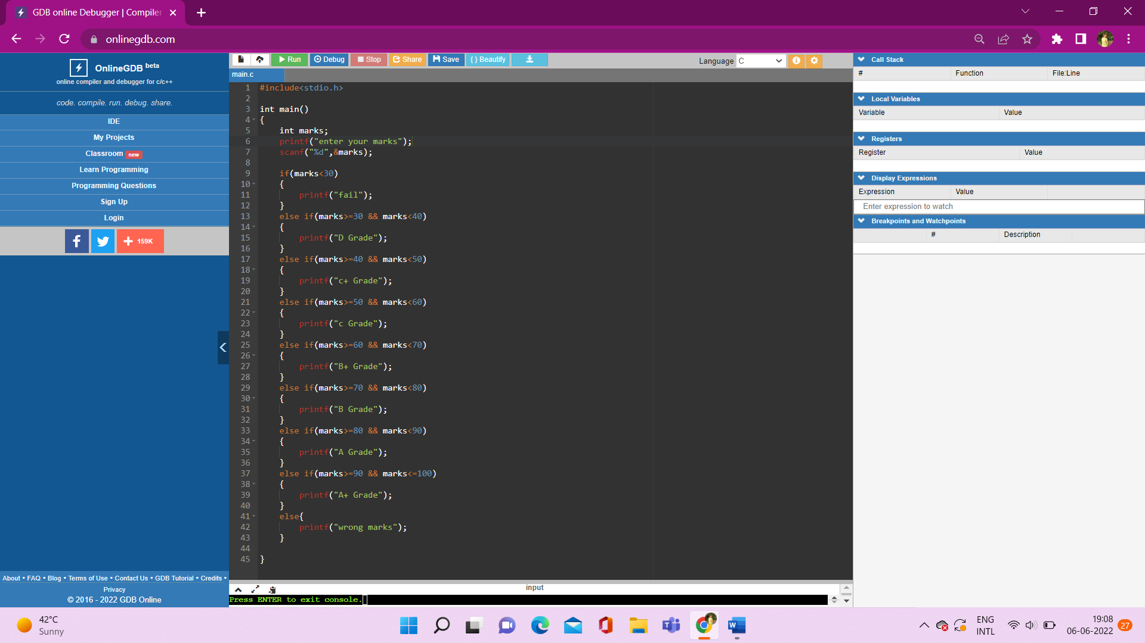

**Output:**

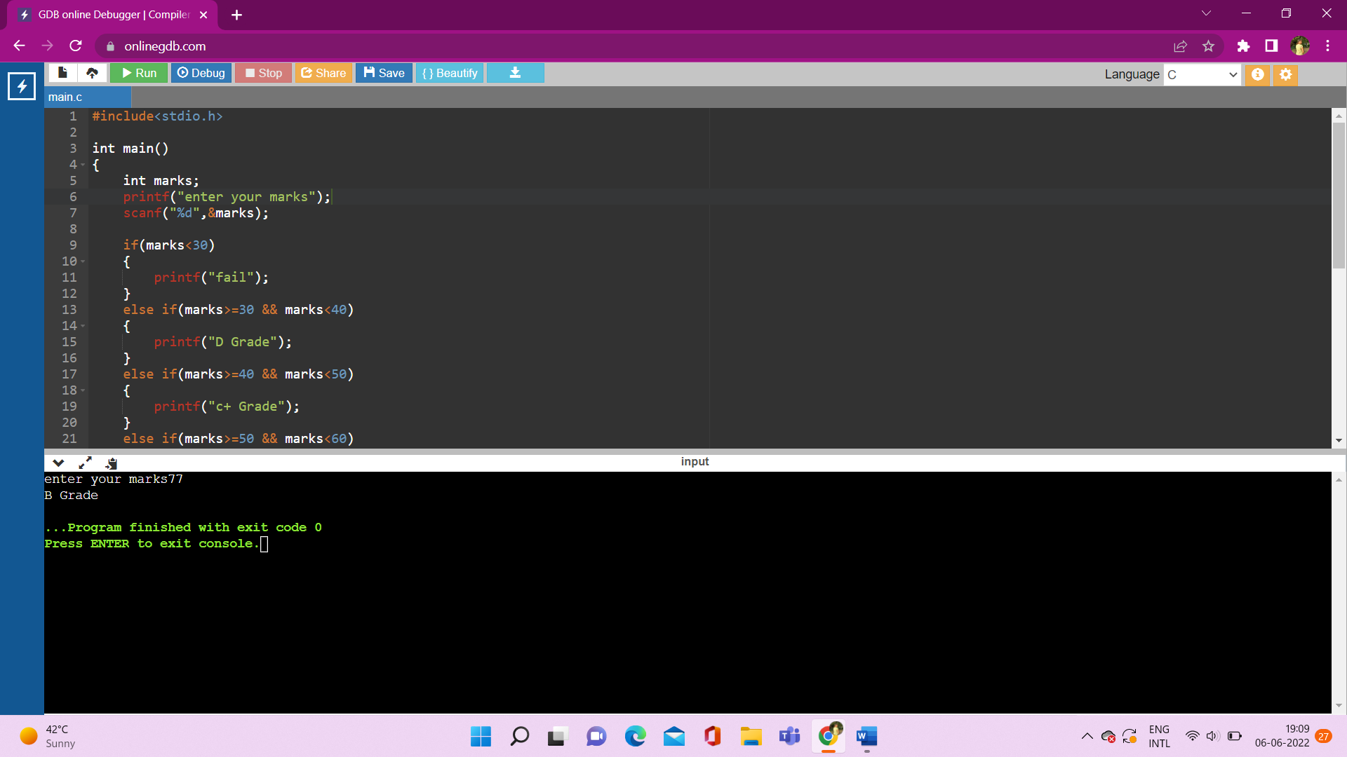

16. if else ladder

**Code:**

#include<stdio.h>

int main()

{

int maths,ss,science,english,computer;

int total=500;

int obtained,per;

printf("enter your maths marks : ");

scanf("%d",&maths);

printf("enter your ss marks : ");

scanf("%d",&ss);

printf("enter your science marks : ");

scanf("%d",&science);

printf("enter your english marks : ");

scanf("%d",&english);

printf("enter your computer marks : ");

scanf("%d",&computer);

obtained = maths+ss+science+english+computer;

printf("\n obtained marks:%d",obtained);

per=obtained*100/total;

printf("\n percentage:%d",per);

if(per<30)

{

printf("\nfail");

}

else if(per>=30 && per<40)

{

printf("\nD Grade");

}

else if(per>=40 && per<50)

{

printf("\nc+ Grade");

}

else if(per>=50 && per<60)

{

printf("\nc Grade");

}

else if(per>=60 && per<70)

{

printf("\nB+ Grade");

}

else if(per>=70 && per<80)

{

printf("\nB Grade");

}

else if(per>=80 && per<90)

{

printf("\nA Grade");

}

else if(per>=90 && per<=100)

{

printf("\nA+ Grade");

}

else{

printf("\nwrong marks");

}

}

**Output:**

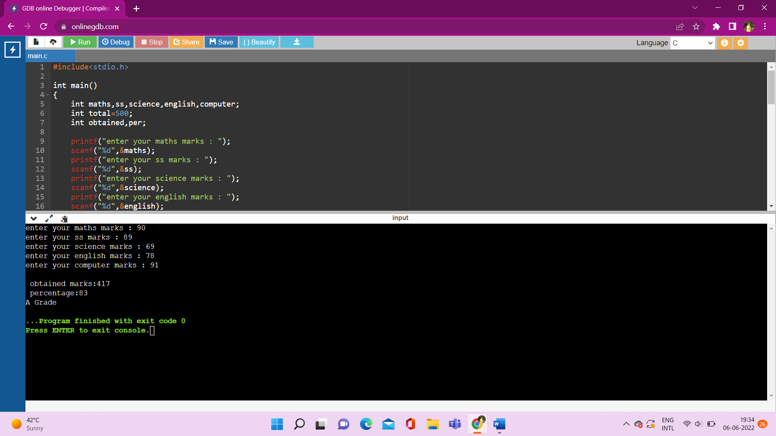

17. switch case

**Code:**

#include<stdio.h>

int main()

{

int days;

printf("enter number of days between 1 to 7:");

scanf("%d",&days);

switch(days)

{

case 1:

printf("monday");

break;

case 2:

printf("tuesday");

break;

case 3:

printf("wednesday");

break;

case 4:

printf("thursday");

break;

case 5:

printf("friday");

break;

case 6:

printf("saturday");

break;

case 7:

printf("sunday");

break;

default:

printf("invalid input!!!");

break;

}

}

**Output:**

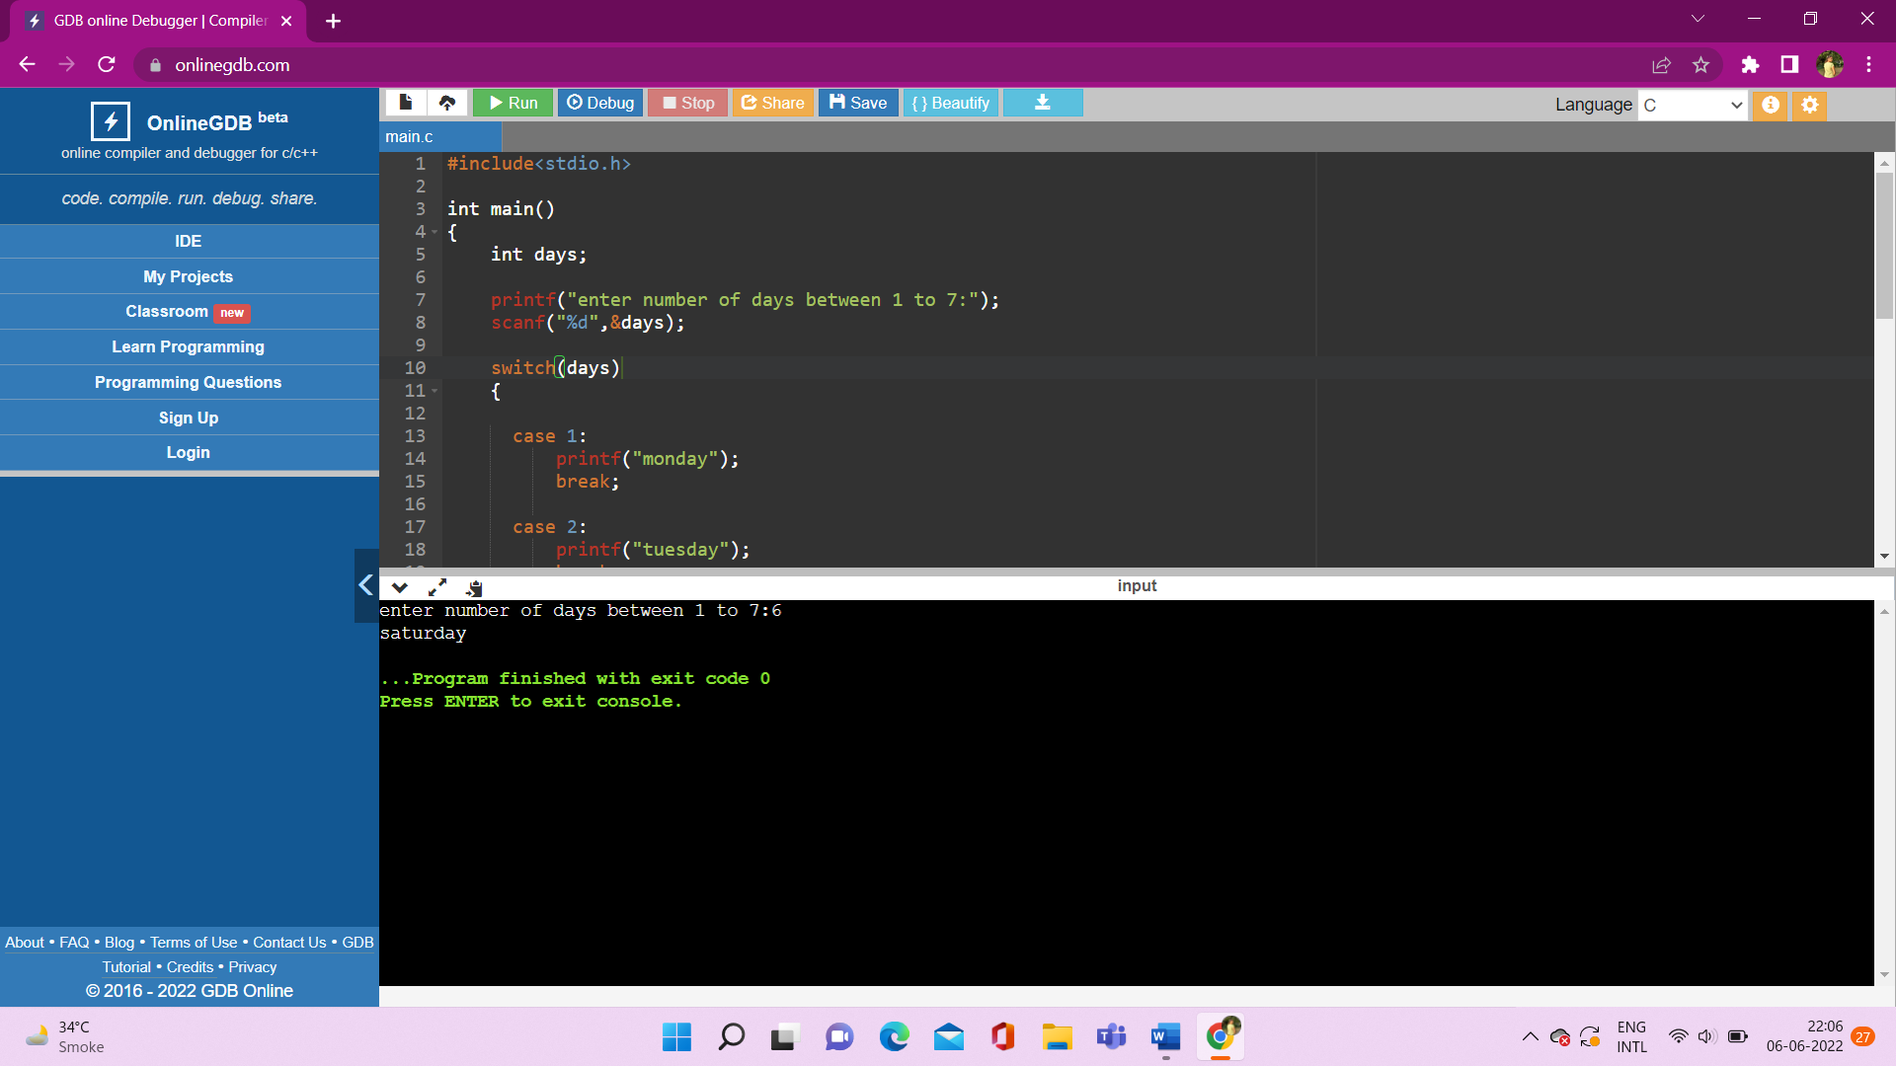

18. switch case – alphabet vowel or consonant

**Code:**

#include<stdio.h>

int main()

{

char alphabet;

printf("enter any alphabet:");

scanf("%c",&alphabet);

switch(alphabet)

{

case 'a':

printf("Vowels");

break;

case 'e':

printf("Vowels");

break;

case 'o':

printf("Vowels");

break;

case 'i':

printf("Vowels");

break;

case 'u':

printf("Vowels");

break;

case 'A':

printf("Vowels");

break;

case 'E':

printf("Vowels");

break;

case 'I':

printf("Vowels");

break;

case 'O':

printf("Vowels");

break;

case 'U':

printf("Vowels");

break;

default:

printf("Consonant");

break;

}

}

**OR**

#include<stdio.h>

int main()

{

char alphabet;

printf("enter any alphabet:");

scanf("%c",&alphabet);

switch(alphabet)

{

case 'a':

case 'e':

case 'o':

case 'i':

case 'u':

case 'A':

case 'E':

case 'I':

case 'O':

case 'U':

printf("Vowels");

break;

default:

printf("Consonant");

break;

}

}

**Output:**

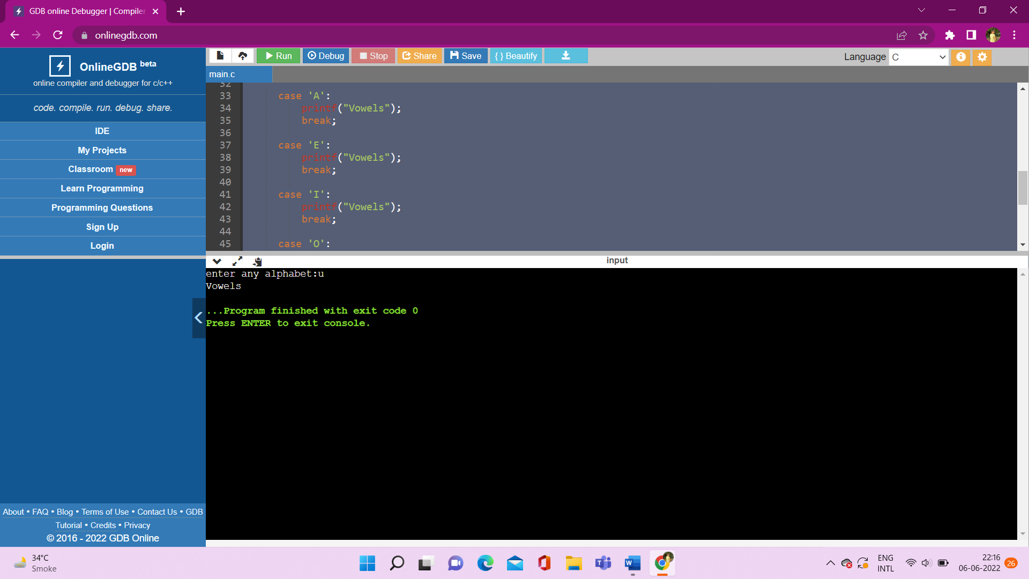

19. write a program to check weather it is a leap year or not

**Code:**

#include<stdio.h>

int main()

{

int year;

printf("enter any year:");

scanf("%d",&year);

if(year%4==0 && year%400==0)

{

printf("leap year");

}

else{

printf("not leap year");

}

}

**Output:**

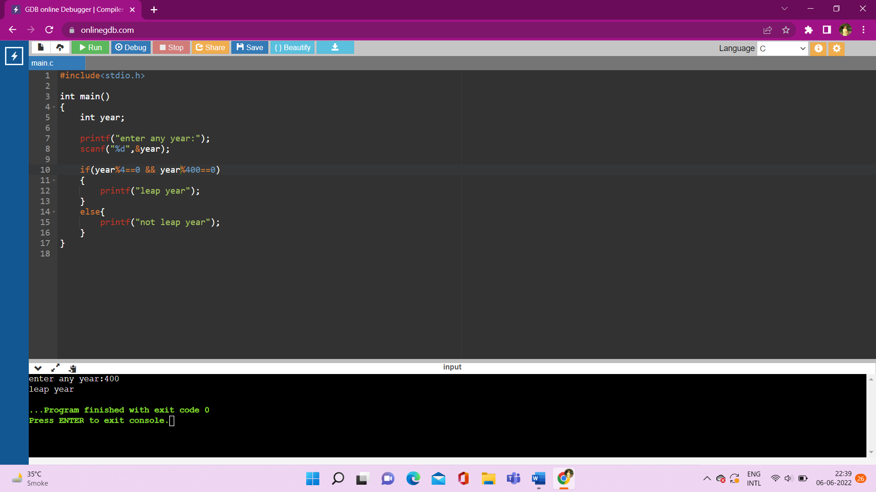

20. Ternary operator

**Code:**

#include<stdio.h>

int main()

{

int a;

printf("Enter a Number:");

scanf("%d",&a);

(a<100 && a>1)? printf("Valid Number"): printf("Invalid Number!!");

}

**Output:**



21. even odd by ternary operator

**Code:**

#include<stdio.h>

int main()

{

int a;

printf("Enter a Number:");

scanf("%d",&a);

(a%2==0)? printf("Even"): printf("Odd");

}

Output:

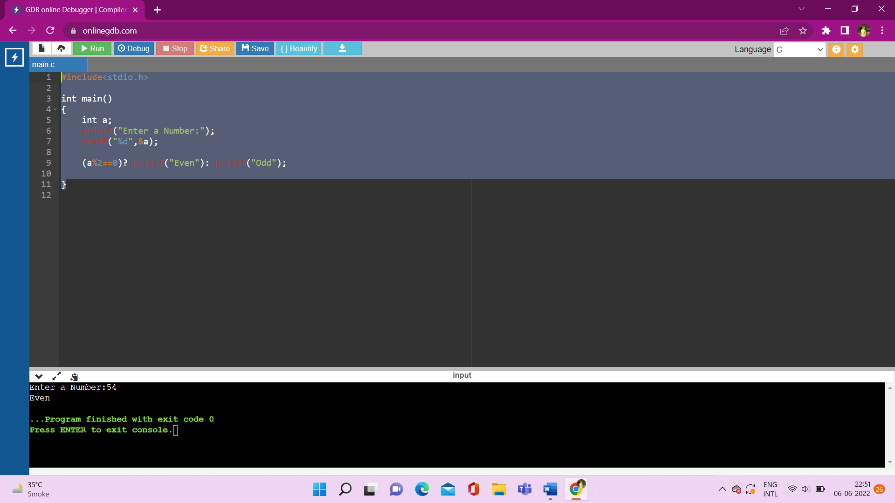

1.Write a program to print half pyramid using * , numbers and characters

• Practical Example:

1. Write a program to demonstrate four categories of function

2. Write a program to demonstrate menu driven calculator using function

3. Write a program to create Quiz application

• Practical Example:

1. Write a program to find factorial using function

2. Write a program to find Fibonacci series using function

• Practical Example :

1. Write a program to print static array

2. Write a program to take 10 values from the user and store them in an array

3. Write a program to demonstrate multi dimensional array

• Practical Example :

1. Write a c program to arrange accepted numbers in ascending and descending order using array.

2. Write a c program for multiplication of matrix

3. Write a c program for addition of two matrix

#include<stdio.h>

int main()

{

int a[2][2];

int i,j;

for (i=0;i<2;i++)

{

for(j=0;j<2;j++)

{

printf("Enter elements for matrix 1:");

scanf("%d",&a[i][j]);

}

}

int b[2][2];

for (i=0;i<2;i++)r

{

for(j=0;j<2;j++)

{

printf("Enter elements for matrix 2:");

scanf("%d",&a[i][j]);

}

}

// printf("\n\n-----2D Matrix_1-----\n\n");

// for(i=0;i<2;i++)

// {

// for(j=0;j<2;j++)

// {

// printf("%d",a[i][j]);

// }

// }printf("\n");

// printf("\n\n-----2D Matrix_2-----\n\n");

// for(i=0;i<2;i++)

// {

// for(j=0;j<2;j++)

// {

// printf("%d",b[i][j]);

// }

// }printf("\n");

}

questions

<https://docs.google.com/spreadsheets/d/1K0-xMuwLIByQwC2S1duI2cEhhRkjK3fMPg7m14CIzIE/edit?usp=sharing>

// palindrome or not

#include<stdio.h>

#include<string.h>

int main(){

char str[100],temp,str1[100];

int length=0,i;

printf("enter a string:");

gets(str);

strcpy(str1,str);

length = strlen(str);

for(i=0; i!=length/2;i++)

{

temp=str[i];

str[i] =str[lengh-1-i];

str[lengh-1-i] = temp;

}

printf("\nReverse string is : %s",str);

if(strcmp(str,str1)==0)

{

printf("\nstring is palindrom");

}

else

{

printf("\nnot palindrom");

}

}

// palindrome of number

#include<stdio.h>

int main()

{

int num,rev=0,rem=0;

printf("enter any number:");

scanf("%d",&num);

printf("number is:%d",num);

while(num!=0)

{

rem=num%10;

rev=(rev*10)+rem;

num/=10;

}

printf("\n reverse number : %d",rev);

}